**READ ME FIRST**

1. Create a “Ryesim” folder in your D drive.
2. Download the soil source code to “D:\Ryesim\Soil Source”; download the crop source code to “D:\Ryesim\Crop Source”.
3. Download this “CALIBRATION_EXAMPLE” folder and save it in “D:\Ryesim”, i.e., under “D:\Ryesim\CALIBRATION_EXAMPLE”, you will see all the files,

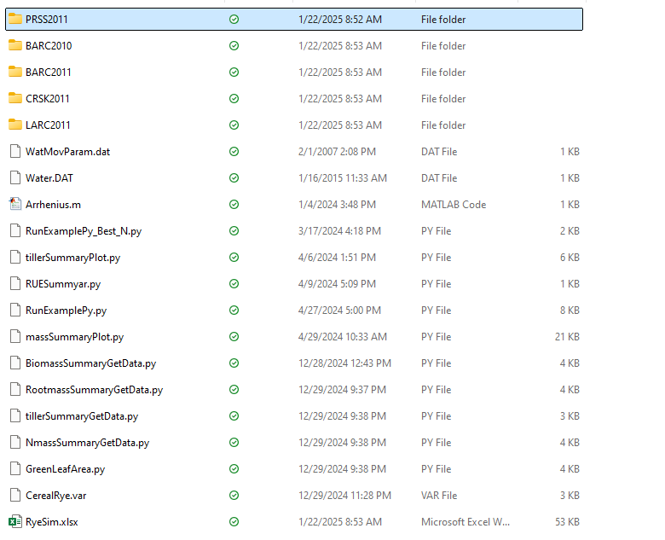

1. Use “RunExamplePy.py” to run all the examples.